Bulk Selection

Readings: Fehr – Chapter 22
Allard – Chapter 13
Jensen – Chapter 9-10

Bulk selection describes a protocol utilized during the inbreeding of populations of self-pollinated species in the development of homozygous lines. Gene frequency changes in populations undergoing bulk selection result from natural selection, in contrast to human imposed selection that is responsible for gene frequency changes under mass selection. The two selection procedures are similar in some field nursery procedural respects, so they could be utilized interchangeably if the breeder is comfortable with the changes that result from natural selection in the propagation environment. Bulk selection is less expensive than mass selection, especially in terms of human capital, and is likely the cheapest form of selection imposed on segregating populations. The seed used to propagate each inbreeding generation is a random sample of seed that was harvested from plants the previous generation. Harvesting operations are typically mechanical (a combine?) rather than hand labor. Bulk selection is much more suited to self- than cross-pollinating species and is totally unsuited for fruit crops and most vegetables.

Bulk selection was developed in Sweden in the early 20th century to handle segregating generations of a winter wheat hybrid population designed to combine winterhardiness and high yield. The genotypic composition of the segregating bulk population was influenced by natural selection during propagation over several Swedish winters. Natural selection increased the frequencies of winter-hardy types in the population.

Implementation:

A very general outline is presented below; most programs have their own subtle, and not-so-subtle, alterations. In the NC State small grains program we do not utilize bulk selection because the number of early generation segregating populations are kept to a manageable number in which we can afford to conduct two generations of mass selection.

Bulk selection would typically be implemented in the F₂ generation and segue into a pedigree system in later generations as described previously for mass selection. But there
are certainly no firm rules on how it should be conducted; for example, if desired, one could implement the pedigree system for the F₂ and / or the F₃ generations followed by bulk selection advance of remaining F₃-derived lines, before extracting homozygous lines in later generations This protocol is known as the modified bulk and will be discussed later.

Season 1. F₂ plants are grown in a large plot that accommodates 2,000 plus plants. The minimum plot size would be three times the size of a typical ‘yield’ plot, but the larger the plot the greater the number of plants undergoing under natural selection and the

GENERALIZED BULK SELECTION PROTOCOL

Season |  | Procedure
1 | Plant 2000 – 5000 F₂ plants.  Harvest plot in bulk.
2 | Plant 2000 – 5000 F₃ plants.  Harvest plot in bulk.
3 | Plant 2000 – 5000 F₄ plants.  Harvest plot in bulk.
4 | Plant 2000 – 5000 F₅ plants.  Harvest plot in bulk.
5 | Plant 2000 – 5000 F₆ plants.  Select individual plants (250)  Keep F_{6:7} seed separate.
6 | Grow one rep of F_{6:7} lines (250)  Harvest best lines in bulk.
7 | Extensive multi-environment  testing begins (F_{6:8}).

smaller the relative proportion of plants growing in the border rows of the plot. Commercial planting rates and cultural practices would be typical, but could be altered to facilitate particular biotic or abiotic selection pressures, i.e., use your imagination. Disease, insect, abiotic and other natural selection pressures should be encouraged. If one is concerned to only select plants exposed to uniform selection pressure then harvest selectively from the center of the plot to avoid border rows and plants next to alleys. Harvesting operations would typically use a combine, and a random sample of F₃ seed would be scooped out of the harvest bag for planting in season 2.
(I would have a difficult time convincing myself not to, at least, run the seed through a blower or over a gravity table at this stage to eliminate poorly developed seeds. This is not a costly exercise and would likely be advantageous. But if I did, it would be mass selection!!!!!).

Seasons 2 through 5: The procedure is repeated over seasons. Individual plants are harvested in season 5 and the lines derived from these plants are evaluated for the characters of interest in the same manner (over replications, locations, and years) as lines derived from other methods of inbreeding. One would likely impose human selection for visibly appealing phenotypes (e.g., short, early, disease and insect resistance) in season 5, so theoretically, this would be a generation of mass selection.

The breeder must carefully choose environments in which natural selection is likely to favor the desired genotypes in the population, i.e., a population segregating for disease resistance should be grown in the presence of the pathogen in order to reduce the productivity of susceptible plants. A population segregating for drought resistance should be grown under moisture stress. A population undergoing bulk selection would rarely be grown in off-season nurseries due to these concerns about an optimum environment with suitable natural selection forces.

Important considerations: The primary concern for the breeder considering bulk selection is summarized in the query: “Is the ability to survive in competition actually related to agricultural worth?” The literature is full or research coming down on both sides of the argument. Genotypic frequencies in a population inbred using bulk selection are determined by four variables associated with natural selection in a heterogeneous population: 1) the genetic potential of a genotype for seed production (number of seed, not necessarily weight), 2) the competitive ability of a genotype to produce that seed in a heterogeneous mix of other plants, 3) the influence of the environment on genotype expression of seed production, and 4) the adequate sampling of seed so that high expression genotypes are included in the next generation. There is no guarantee that specific F₂ plants will, or will not, have progeny in the F₃ or later generations. There is no way to predict the genetic variability for a character in any generation. If the four variables above favor the desired genotype, their frequency will increase; if not then you are out of luck.

Kervella and Fouilloux (1992. Euphytica 60:185-192) studied sampling losses in bulk selection, or losses of lines of descent due to the failure to include seed produced by the line in the sample compiled for subsequent generation propagation. They examined the influence of a range of variables including the number of plants included in the original bulk, the number of seeds produced by each plant, and heritability of seed production. They found that the extinction rate of lines typically exceeded 20% in one generation of bulk selection and if plants produced roughly equivalent numbers of seeds, the extinction rate can be 66% by the end of the fourth cycle of bulk selection. Multiplying the size of the population each generating reduces the extinction rate, but is it generally not a practical solution. However, this does argue for using the largest plots feasible from the inception. The loss of variation due to extinction of lines during bulk propagation can be compensated, somewhat, by the expression of within-line variation.

Bulk selection suffers from an identity crisis, because there really are two broad categories of bulk selection: 1) practical short-term, say, F₂ through F₆ generation bulk selection and 2) the long-term ‘evolutionary’ breeding method. They should not be confused because they are separate entities. If one selects out of a population that has undergone bulk selection for 15 to 20 generations of propagation, the impact of natural selection will be much greater than in a population that has undergone bulk selection for four or five generations of propagation.

Research results: Although bulk selection is used to some extent in cultivar development in combination with other techniques, articles dealing with bulk selection are relatively infrequent today. Nevertheless it was a very popular subject from the 1940’s through the 1970’s, and is making a come-back with the current enthusiasm for evolutionary-participatory breeding methods in less developed regions and for organic systems. Evidence for the value of natural selection, either beneficial or detrimental from the viewpoint of a plant breeder, comes from two types of experiments: 1) survival among pure line genotypes in designated mixtures, and 2) survival of different plant types in hybrid-derived segregating populations.

One of the classic papers on survival among pure line genotypes in designated mixtures was by Suneson and Weibe (1942, J. Am. Soc. Agron 34:1052-56). They mixed equal proportions of four barley varieties and evaluated the compositional change through an annual census over nine seasons of bulk selection. In adjacent plots they evaluated the yielding ability of each of the four varieties in pure stand (Tables 13-2 and 13-3 below from Allard’s book).

A notable feature of the experiment was the way ‘Atlas’ quickly predominated in the mixture; almost to 50% after four years and almost to 90% after nine years. The cultivars ‘Hero’ and “Vaughn’ displayed the opposite trend and they were quickly depleted in the mixture. The yield differences between the cultivars in pure stand were relatively small, and in fact the poorest competitor in the mixture, Vaugn, actually displayed the highest yield in pure stand. Thus, the experiment failed to show an association between yielding ability in pure stand and competitiveness in mixtures. Subsequent research perhaps explained some of the underlying causes of the observed differences. While Atlas accounted for 55% of the heads in a mixed stand, it actually had 40% fewer heads than Vaugn in a pure stand. It was also found that Atlas had a larger root system than Vaughn. This latter characteristic could account for its ability to produce more heads in a mixture, which could be reflected in a competitive edge.

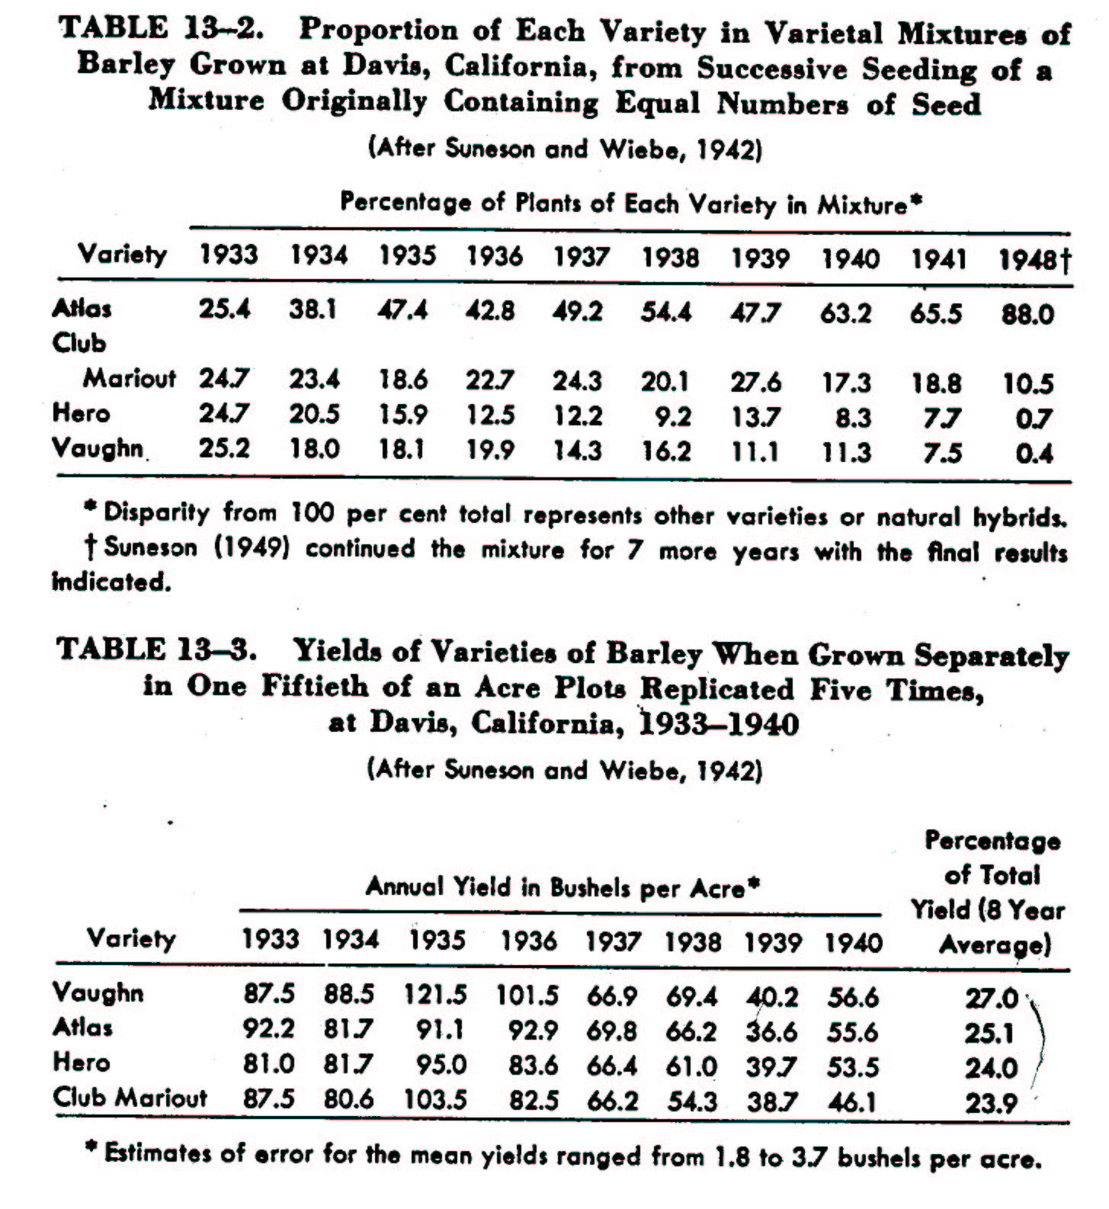
One does not need to mix pure lines with grossly different morphological characteristics to see the effects of natural selection. A multiline cultivar is comprised of a mixture of several near isogenic lines (NILs), which are lines that are phenotypically very similar but differ from each other by a single major resistance gene.

Murphy, J.P. et al, (1982). Compositional stability of an oat multiline. Euphytica 31:33-40.

The particular multiline examined was created by mixing equal proportions of the five NILs in Table 1 (below). The multiline was divided into two parts and one part was advanced through four generations with fungicide applications to control rust, and the second part was advanced through four generations under human enhanced rust epiphytotics. Overall, the NILs had similar phenotypes and one could not make a visually census. Rather a large sample of remnant seed was utilized to develop derived lines from each generation and the annual census was made by recording the resistance : susceptibility reaction of each derived line to a series of rust isolates, and comparing the results to known reactions for the five NILs.

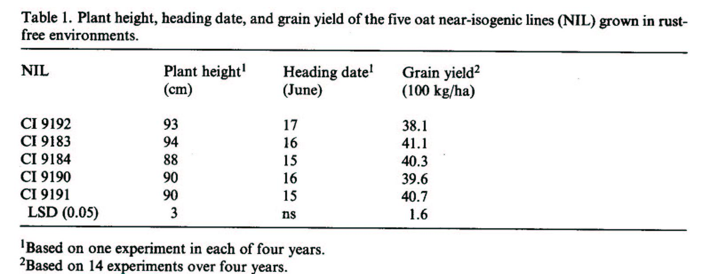

Any compositional shifts that occurred in the rust-free line of descent were due to plant-to-plant interactions. One NIL (CI 9192) significantly decreased and another (CI 9184) had a large, but non-significant increase (below). The line that decreased in frequency had the lowest yield in pure stand (above), but it was not significantly different from another line that remained stable over generations.
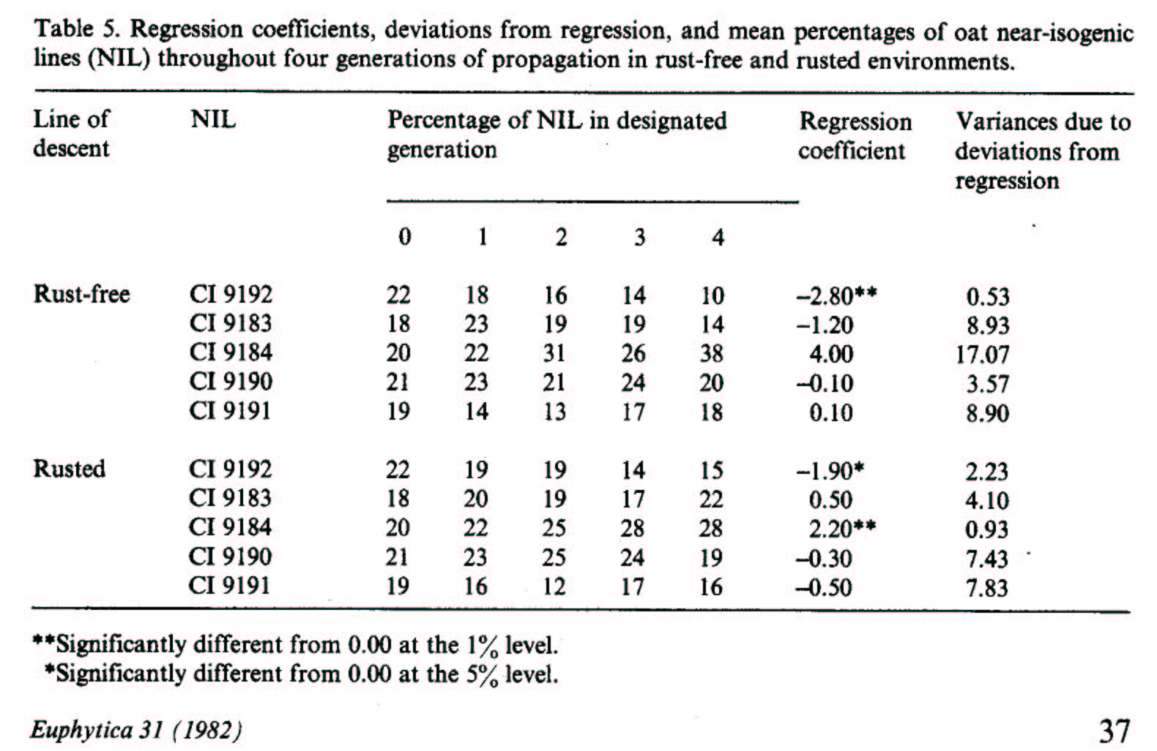
Trends in NIL composition in the rusted line of descent were similar to the rust-free line of descent in that CI 9192 significantly decreased and CI 9184 significantly increased. Thus, the rust environment did not seem to be a factor that could override shifts in NIL composition caused by differential survival capabilities among the NILs. It was not clear why the two NILs changed over time.

The population components investigated in these two experiments were pure lines, which may not necessarily relate to the bulk selection method as typically used today. The predominant use of bulk selection is to “self-in-bulk” until near homozygosity. Segregation will occur in bulks developed from hybridization, so the competing genotypes are not expected to be constant from one generation to another. In the previous studies it was not possible to assay for the survival of an allele or allelic combination per se because that allele or allelic combination was always associated with all other alleles in the genotype. Only when homozygosity is approached (F₆ to F₈) will the situation begin to represent that of pure line mixtures.

Hamblin, J. 1977. Plant breeding interpretations of the effects of bulk breeding on four populations of beans (Phaseolus vulgaris L.). Euphytica 26:157-168.

The impact of bulk selection from the F₂ through F₆ generations on yield and its components were examined in two high-yielding and two low yielding two parent hybrid populations of beans. Residual seed per se rather than derived lines developed with the residual seed was utilized to plant 24 plots per replication (i.e., the four parents, and the four crosses in each of the F₂, F₃, F_{4,} F₅ and F₆ generations). Each plot consisted of 120 plants spaced 18cm apart in a square, and data on individual plants were recorded.

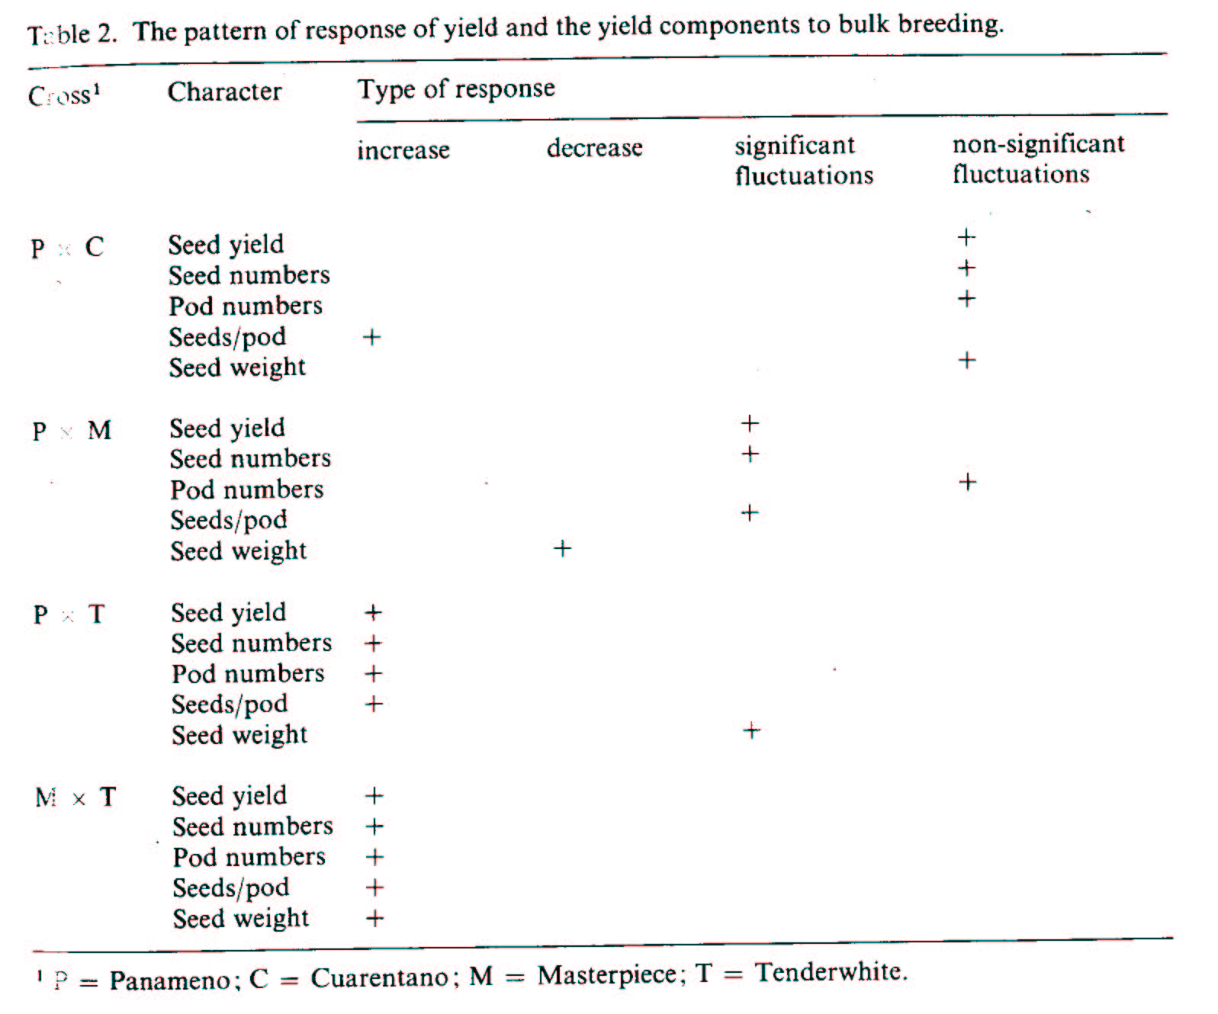
Four patterns of response over bulk selection generations were observed for the five plant characters examined (above). Over time, the character 1) increased, 2) decreased, 3) had statistically significant but random fluctuations, and 4) had non-significant random fluctuations. The high yielding crosses (PxC and PxM) tended to display random fluctuations, but the lower yielding crosses (PxT and MxT) displayed increases in means for nine of the 10 plant traits. This probably resulted from the fact that low yielding crosses likely contained a higher frequency of poorly adapted genotypes which were lost over generations. The author underscored the point that the method did not lead to a loss of high yielding genotypes and as such should be considered for beans because of the cost efficiency of the method.

Jennings and Herrera., 1968. Survival of different plant types in hybrid-derived segregating populations. Evolution 22:332-336.

This manuscript demonstrated a common phenomenon reported when natural selection is applied to populations segregating for major differences in plant height. The hybrid population resulted from a cross between a tall rice cultivar Peta and a dwarf cultivar Taichung Native 1. Plant height segregated on a monofactorial basis, so the expected frequencies of tall and short plants in each generation of inbreeding were known. Two lines of descent were followed from the F₂ through F₆ generations; one line of descent was propagated under a high nitrogen fertility regime and the second was propagated under a low nitrogen fertility regime.

% Dwarf
% Dwarf Observed____
Expected Low N High N
F₂ 25 24.9 24.9
F₃ 37.5 31.2 22.4
F₄ 43.8 33.5 18.9
F₅ 46.9 28.3 14.2
F₆ 48.5 23.7 8.8

The dwarf plants outyielded the tall by a mean of 35% in pure stand, but in a mixture the tall genotypes had vigorous vegetation which gave them a decided competitive advantage for light interception. This resulted in a high differential in reproductive rates which caused the rapid demise of the short, high yielding genotypes. This disadvantage was observed through the less than expected frequencies of short plants in later generations of inbreeding in both fertility regimes (above). However, the disadvantage was intensified under the high N regime. Jennings recommends rouging the population to remove the good competitors in order to eliminate the bad effects of competition in segregating populations.

Although there are many examples of changes brought about by natural selection during inbreeding in the literature, one should not assume that changes in important allelic frequencies are certain with this procedure. One may be dealing with a situation where the frequencies of desirable genotypes remain relatively stable, as opposed to increasing or decreasing over generations. In this scenario, given that bulk selection is a cost effective option, it might be the most desirable option. I believe (but based on zero research conclusions from my program) that this is likely the case when one advances populations developed from adapted x adapted crosses under bulk selection in the presence of mild biotic and abiotic stresses for only two to three generations. The next paper lends credence to my theory that such an outcome can occur.
Busch, R. H., and D. Luizzi. 1979. Effects of intergenotypic competition on plant height, days to heading, and grain yield of F₂ through F₅ bulks of spring wheat. Crop Sci. 19:815-819.

These authors examined changes in plant height, days to heading and grain yield in six wheat populations advanced under bulk selection from the F₂ through F₅. The parents differed for plant height and photoperiod sensitivity.

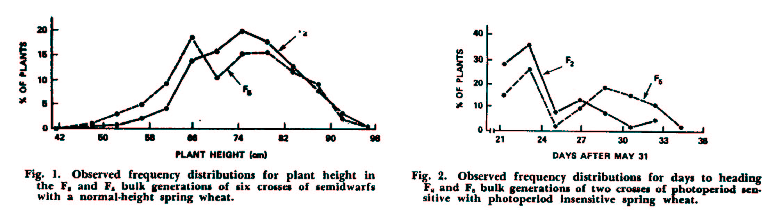

Overall, there were only relatively minor shifts in plant height and maturity frequencies when the F₂ and F₅ bulks were compared (above). Greater variation for the two traits was observed in the F₅ generation, but that would be expected based on increased frequencies of homozygous contrasting types in the later generations. The F₅ generation had a higher frequency of later heading genotypes, but the populations segregated into two clear photoperiod classes with a sufficiently high frequency of early maturing segregates to permit meaningful selection. The authors also reported that the correlations between F₂ and F₅ bulk yields were high and positive. The authors concluded that the bulk selection technique had advantages for their (North Dakota) environment.

Suneson, C. A. 1956. An evolutionary plant breeding method. Agron. J. 48: 188-191.

Suneson proposed the concept of evolutionary plant breeding based on the propagation of populations under bulk selection over many generations (10, 20, 30 plus). He showed data from four ‘composite crosses’ of barley that supported the idea that bulk selection can be a powerful evolutionary force for good over time. Composite cross populations were formed by intercrossing large numbers of genetically diverse genotypes. For example, Composite Cross II was based on intercrossing 28 diverse cultivars of barley (378 crosses). Another composite cross population included a segregating male sterility allele which facilitated a continuously low level of recombination in the self-pollinating barley. All composite populations were propagated in approximately 1/50 acre plots over numerous generations in typical barley production environments in California.

The yielding ability of the composite cross populations were compared periodically with that of the cultivar Atlas 46 using remnant seeds from various generations (below). The composite populations all stated out significantly inferior to Atlas 46 in yielding ability in early generations, but all four showed remarkable gains over time. Three of the populations were similar to the check by F₈ to F₂₀. Thus, natural selection did cause gradual and significant increases in yielding ability, which suggested that the highest performing genotypes produced the most offspring and were the best competitors.

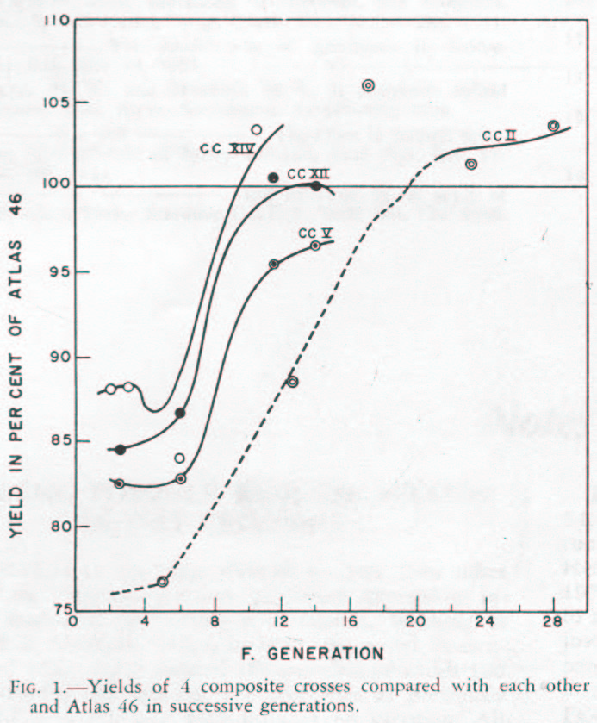

Soliman and Allard (1991. Crop Sci. 31:705-708) re-examined the composite cross populations in a series of comparisons with four Californian cultivars. In addition to mean grain yield they utilized the Eberhart and Russell stability analysis we discussed previously, to compare the response (regression coefficient) of the entries to changing productivity and the stability of that response as measured by the deviations of data points around the regression line.

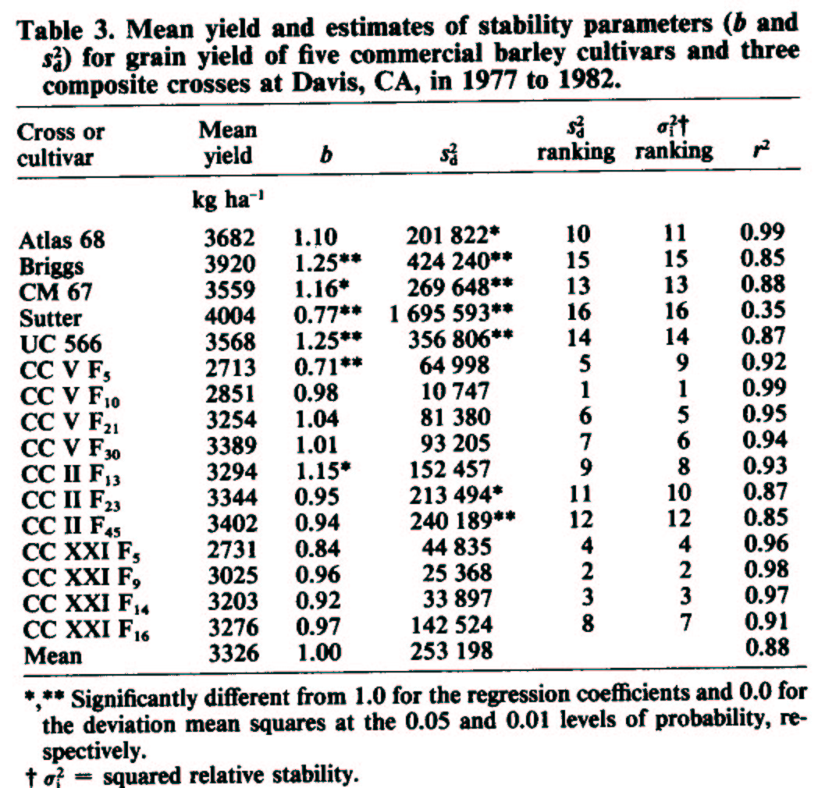
The modern cultivars outyielded the composite cross populations suggesting that the evolutionary method did not keep pace with other breeding procedures as far as yielding ability. Nevertheless the ability of the evolutionary method to improve composite cross populations was reaffirmed by comparing yields of early and late composite cross generations. The modern cultivars were generally better able to respond to higher production environments (higher b values), while the composite cross populations were generally more stable (smaller deviations from regression). The genetic buffering in the composite cross populations better prepared them to handle environmental fluctuations. This likely was a reflection, in part, of the greater disease resistance of the composite cross populations.

The authors concluded that if disease resistance and yield stability was most important then the composite cross method had merit because of its low cost, efficient approach. However, if yield potential is a major goal, then the evolutionary approach is not suitable.

Murphy et al, (2005. Renewable Agric. Food Systems 20:48-55) argue for the combination of the evolutionary breeding approach with participatory plant breeding to develop heterogeneous, stable, site specific cultivars for farmers in less developed regions, and organic producers in general. Participatory plant breeding has emerged over the past decade as a cooperative approach between public breeders and farmers to identify cultivars that are uniquely suited to low productivity, high stress environments. It is argued that modern, high input, widely adapted cultivars are not necessarily the best, or most stable performers, in all low productivity, high stress environments. The universality of this phenomenon is questionable, but specific cases are documented and suggest that alternative approaches should be considered. The authors present a well written and comprehensive outline as to how such a scheme could be implemented. The paper is an excellent review of many aspects of the bulk method, potential problems with current mainstream breeding approaches, and outlines a protocol for an alternative scheme.

Advantages of the bulk selection method:

- The bulk selection method is a very straightforward and cost efficient approach to maintaining populations during inbreeding.

- Natural selection is permitted to occur, which can increase the frequency of desired genotypes compared with an unselected population.

- It is readily used in conjunction with mass selection. The cynic might say that the bulk method is used by people who intended mass selection, but ran of out time or were too lazy to carry it out.

- Selection in each generation involves a different environment (year) which provides a good opportunity for expression and selection of important characters.

Disadvantages of the bulk selection method:

- Desirable plants in one generation are not necessarily represented in the next generation. Genotype frequencies and genetic variability cannot be readily defined.

- Natural selection may favor undesirable genotypes. It does not follow that characteristics which make a domesticated species useful to humans are necessarily associated with survival, e.g., dwarf types, non-shattering. Thus, natural selection may prove counterproductive.

- Bulk selection is not suited to greenhouse or off-season nurseries. If cannot use off-season nurseries there will be an associated increase in the length of time for cultivar development compared with other methods of breeding.

